A prayer guide to
VISITA IGLESIA
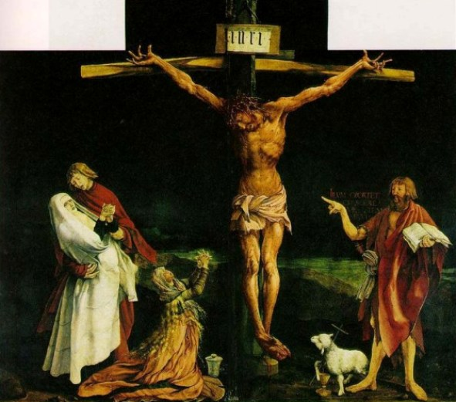
Visiting seven churches to commemorate and accompany
Jesus’ seven passages and stops
from the Last Supper to Calvary
By Paty Martinez
Contents
FIRST VISIT: Jesus walks from the Last Supper to the Mount of Olives 2
SECOND VISIT: Jesus was driven from the Garden of Olives to the house of Annas 3
THIRD VISIT: Jesus was brought from the house of Annas to the house of Caiaphas. 4
FOURTH VISIT: Jesus’ passage from the house of Caiaphas to Pilate's praetorium 5
FIFTH VISIT: Jesus was led from the house of Pilate to the house of Herod 6
SIXTH VISIT: Jesus was led for a second time to Pilate. 7
SEVENTH VISIT: Jesus' journey to Calvary, carrying the Cross 8

FIRST VISIT: Jesus walks from the Last Supper to the Mount of Olives
Jesus, teach me to always accompany you!
In the name of the Father ….
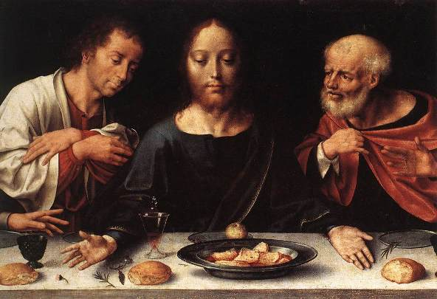
Gospel
Now as they were eating, Jesus took bread, and blessed, and broke it, and gave it to the disciples and said, "Take, eat; this is my body." And he took a cup, and when he had given thanks he gave it to them, saying, "Drink of it, all of you; for this is my blood of the covenant, which is poured out for many for the forgiveness of sins. I tell you I shall not drink again of this fruit of the vine until that day when I drink it new with you in my Father's kingdom." And when they had sung a hymn, they went out to the Mount of Olives. (Mt. 26: 26-28,30,36).

Reflection
Jesus’ passage from the Upper Room to the Mount of Olives is an act of obedience to the command of the Father to redeem us. In his Last Supper, he gave to us everything he can give: his Body and Blood in the Eucharist. This sacrifice will now be made visible as he is delivered into the hands of his enemies for the salvation of men. He voluntarily surrenders himself to the sufferings of the Passion. For us, the meditation on the Passion of Jesus Christ must be the most pleasing and dearest devotion, because we are not only the cause of his suffering, but also its goal and fruit. Christ suffered for us to free us from our sins.
Our Father ... Hail Mary ... Glory ...
Prayer
Oh Jesus, I adore you and I give thanks for the blood you shed since you were a child and for the painful steps you took in order to save me, especially for that trek you took from the Upper Room to the Garden of Gethsemane to begin your Passion. Please grant me and all Christians the virtue of mortification and the gift of fear of God. Amen.

SECOND VISIT: Jesus was driven from the Garden of Olives to the house of Annas
Lord, may I never cease to pray!
In the name of the Father ...
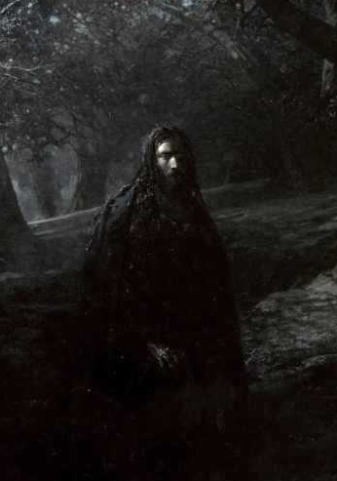
Gospel
And he came out, and went, as was his custom, to the Mount of Olives; and the disciples followed him. And when he came to the place he said to them, "Pray that you may not enter into temptation." And he withdrew from them about a stone's throw, and knelt down and prayed, "Father, if thou art willing, remove this cup from me; nevertheless not my will, but thine, be done." And being in an agony he prayed more earnestly; and his sweat became like great drops of blood falling upon the ground. Then they seized him and led him away, bringing him into the house of Annas, the high priest. (Lk 22.39 -54; Jn 18: 13.)
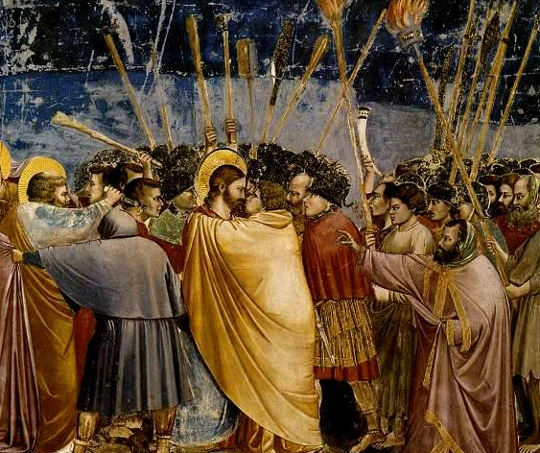
Reflection
God is my Father, even though he may send me suffering. Jesus suffers, to fulfil the Will of the Father... And I, who also wish to fulfil the most holy Will of God, following in the footsteps of the Master, can I complain if I too meet suffering as my travelling companion? It will be a sure sign of my sonship, because God is treating me as he treated his own Divine Son. (St. Josemaria).
Our Father ... Hail Mary ... Glory ...
Prayer
My Lord Jesus Christ, I adore you and thank you for the painful journey you took in order to save me, when after having been arrested in the Garden of Olives and having perspired blood, you were taken to the house of Annas. I beg you to grant me the grace to carry all adversities with love and patience. Please let me always know that I am your child. Amen.

THIRD VISIT: Jesus was brought from the house of Annas to the house of Caiaphas.
Jesus, may I learn how to speak and how to be silent.
In the name of the Father ...
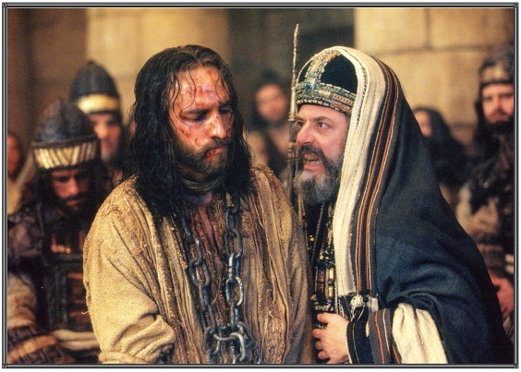
Gospel
Then those who had seized Jesus led him to Caiaphas the high priest. Many false witnesses came forward. And the high priest stood up and said, "Have you no answer to make? What is it that these men testify against you?" But Jesus was silent. And the high priest said to him, "I adjure you by the living God, tell us if you are the Christ, the Son of God." Jesus said to him, "You have said so. But I tell you, hereafter you will see the Son of man seated at the right hand of Power, and coming on the clouds of heaven." Then the high priest said, "He has uttered blasphemy. Why do we still need witnesses? You have now heard his blasphemy. What is your judgment?" They answered, "He deserves death." Then they spat in his face, and struck him; and some slapped him, saying, “Prophesy to us, you Christ! Who is it that struck you?" (Mt. 26, 57-68).
Reflection
Jesus took upon himself the pains of the world, and so we cannot reduce the mystery of our redemption to a simple meditation. It demands of us a living response of faith to unite our sufferings to the saving sufferings of Jesus, and our sentiments of brotherly solidarity with all humans who are suffering today.
Our Father ... Hail Mary ... Glory ...
Prayer
Lord Jesus, I adore and praise you for the meekness and docility which you practiced while being taken from the house of Annas to Caiaphas. I adore and praise you for the Precious Blood you shed during your scourging at the pillar. I beg you to grant us the virtue of chastity and the gift of looking at all created things with the light of faith. Amen.

FOURTH VISIT: Jesus’ passage from the house of Caiaphas to Pilate's praetorium
My sins were the cause of your Passion! Help me, Lord, never to offend you!
In the name of the Father ...
Gospel
Then they led Jesus from the house of Caiaphas to the praetorium. It was early. They themselves did not enter the praetorium, so that they might not be defiled, but might eat the passover. So Pilate went out to them and said, "What accusation do you bring against this man?" They answered him, "If this man were not an evildoer, we would not have handed him over." Pilate said to them, "Take him yourselves and judge him by your own law." The Jews said to him, "It is not lawful for us to put any man to death." This was to fulfill the word which Jesus had spoken to show by what death he was to die. (Jn.18: 28-32).
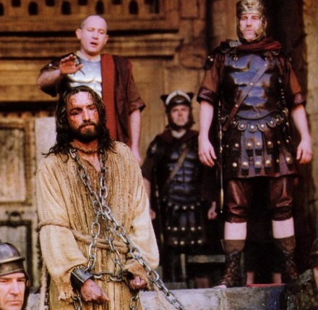

Reflection
The Passion of my Heart is not over. The nails, the thorns, and the Cross have not ended here... I suffered throughout my life because I saw, down through the centuries, how the grace which I suffered so much to obtain was trampled down upon by men ... and today I also suffer and I cry for many dead souls who are about be lost (Concepción Cabrera).
Prayer
Jesus, I love you and thank you for the arduous journey you made from the house of Caiaphas to that of Pilate in order to save me. I love you and thank you for the Precious Blood that you shed during the crowning with thorns. I pray that you comfort all those who suffer. Grant me the virtue of generosity and the gift of doing the right things in my life. Amen.

FIFTH VISIT: Jesus was led from the house of Pilate to the house of Herod
Lord, may I never be ashamed of showing myself as your disciple!
In the name of the Father ...
Gospel
When Pilate heard this, he asked whether the man was a Galilean. And when he learned that he belonged to Herod's jurisdiction, he sent him over to Herod, who was himself in Jerusalem at that time. When Herod saw Jesus, he was very glad, for he had long desired to see him, because he had heard about him, and he was hoping to see some sign done by him. So he questioned him at some length; but he made no answer. The chief priests and the scribes stood by, vehemently accusing him. And Herod with his soldiers treated him with contempt and mocked him; then, arraying him in gorgeous apparel, he sent him back to Pilate (Lk.2: 6-11).
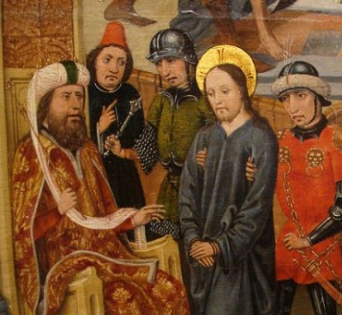
Reflection
On this visit we accompany our Divine Master on the road he took from Pilate's house to the palace of King Herod, another of his seven trips that he himself traced with his own blood in order to carry out the work entrusted to him by his Heavenly Father, the redemption of mankind. We consider the insults and humiliations to which he was subjected, so that we will learn to cope with ridicule and misunderstandings.
Our Father ... Hail Mary ... Glory ...
Prayer
Oh Jesus, I love you and thank you for this arduous journey you took from Pilate's house to the palace of King Herod in order to save me. I love and thank you for the Precious Blood that you shed at the Crucifixion when your hands were nailed to the Cross. I humbly ask for the conversion of sinners and also, may you deign to grant us the virtue of diligence and the gift of fortitude. Amen.

SIXTH VISIT: Jesus was led for a second time to Pilate.
Jesus, give me sincerity so that I do blame others for my sins!
In the name of the Father ...
Gospel
Pilate then called together the chief priests and the rulers and the people, and said to them, "You brought me this man as one who was perverting the people; and after examining him before you, behold, I did not find this man guilty of any of your charges against him; neither did Herod, for he sent him back to us. Behold, nothing deserving death has been done by him; I will therefore chastise him and release him." But they shouted all the more, "Let him be crucified." And their voices prevailed. So when Pilate saw that he was gaining nothing, he took water and washed his hands before the crowd, saying, "I am innocent of this righteous man's blood; see to it yourselves." (Lk.23:13-23; Mt. 27:34)
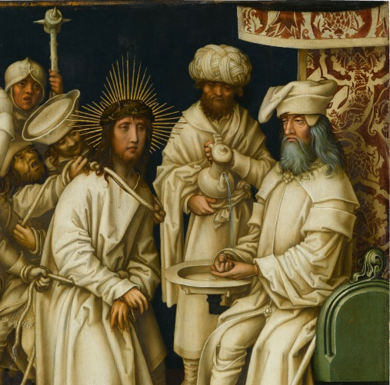
Reflection
There is the kind of attitude which develops if one is unable to penetrate this mystery of Jesus. Some people tend to see Christianity as a collection of devout practices or acts of piety, failing to realize the relation between them and the circumstances of ordinary life, including the urgency to meet the needs of other people and remedy injustice. I would say that anyone who has that attitude has not yet understood the meaning of the incarnation. The Son of God has taken the body and soul and voice of a man; he has shared our fate. (St. Josemaria)
Our Father ... Hail Mary ... Glory ...
Prayer
Lord, I adore and thank you for the arduous journey that you made from the palace of Herod, to go for a second time before Pilate in order to save me. I adore and thank you for the blood you shed when your feet were nailed to the wood of the Cross. I ask you to grant us the virtue of charity and the gift of understanding the profound truth of everything you teach us in our holy Faith.

SEVENTH VISIT: Jesus' journey to Calvary, carrying the Cross
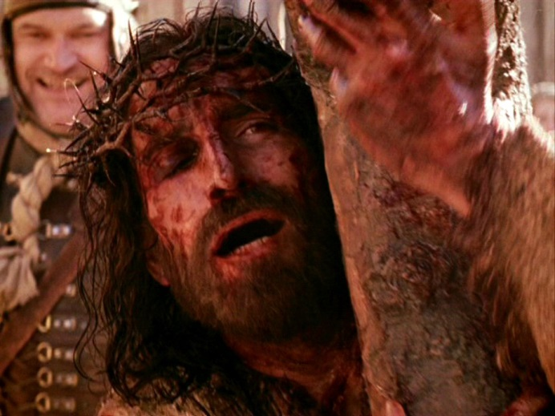
Lord, make me understand that my cross is to fulfill well, with love, all the duties of each day!
In the name of the Father...
Gospel
And when they had mocked him, they led him away to crucify him. And there followed him a great multitude of the people, and of women who bewailed and lamented him. But Jesus turning to them said, "Daughters of Jerusalem, do not weep for me, but weep for yourselves and for your children. For if they do this when the wood is green, what will happen when it is dry?" Two others also, who were criminals, were led away to be put to death with him. And when they came to the place which is called The Skull, there they crucified him. And Jesus said, "Father, forgive them; for they know not what they do." And his clothes were distributed by lot, the people stood beholding. These rulers scoffed, saying, "He saved others, let him save himself if he is the Christ of God, the chosen". The soldiers also mocked him, coming up and offering him vinegar, and saying, "If you are the King of the Jews, save yourself!" (Mt.27: 31; Lk 23:27-36)
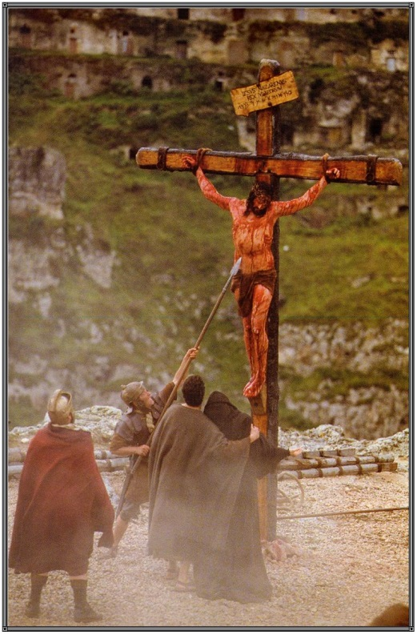
Our Father ... Hail Mary ... Glory ...
Prayer
Lord, please grant me the grace not to be self-centered and self-important, so that I will have true wisdom which consists in loving you above all things, now and forever and ever. Amen.
St. Pope John Paul II:
I urge you to live intimately with great love these holy days and to participate in liturgical services, in order to penetrate more deeply into the content of faith, coming out with resolutions of a genuine commitment to consistency and Christian life.
Let us travel the way of the Passion of Christ with Mary, contemplating Good Friday with the light of his victorious Easter, in order to learn that all suffering must be accepted and interpreted in the light of the glorious resurrection and, above all, to encounter Christ who loved us and gave himself for us. (Gal. 2:20).

Original: Guía para hacer la Visita a las 7 casas, El Jueves Santo. In Evangeliza fuerte, April 2011. By Paty Martinez. Translated to English and edited by Dr. Raul Nidoy.

